# Practical Project: Guess A Number

This is additional practical project and it **is not mandatory and it is not included in the final score**. The main purpose is to use gained knowledge in different type of problems and to improve your portfolio and GitHub skills.Logo

Today we will make the console game "Guess A Number". "Guess A Number" is a game in which your opponent, "**the computer**" chooses a **random** number between "1 and 100" and your task is to **guess** this number. After each number you enter, the computer will give you a **hint** of whether the number is **greater** or **less** than the number you selected until you guess the **correct** number:

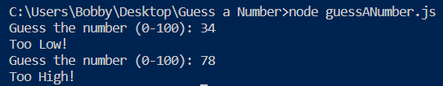

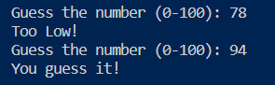

## Create GitHub Repository

We already have a GitHub account created, so we're moving directly to creating a new repository.

Create a **new repository** from: <https://github.com/new>. Choose a **meaningful name**, e. g. "GuessANumberByUsername" add a **short description** and make your repo **public**:

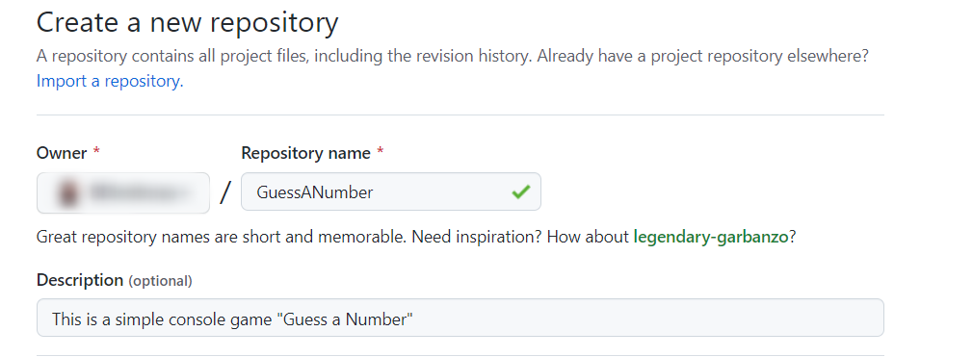

|  |  |
| --- | --- |
|  | Please choose **your original and unique name** for your project!  Your GitHub profile should be **unique**, not the same as your classmates.  You can follow this tutorial, but you can also **make changes** and **implement your project differ** from your classmates. |

Also, **add a** README.md file and .gitignore **for Visual Studio**. In Git projects, the .gitignore **file** specifies which files from your repo are not part of the source code and should be ignored (not uploaded in the GitHub repo). Typically in GitHub, we upload in the repo **only the source code,** and we don’t upload the compiled binaries and temp files.

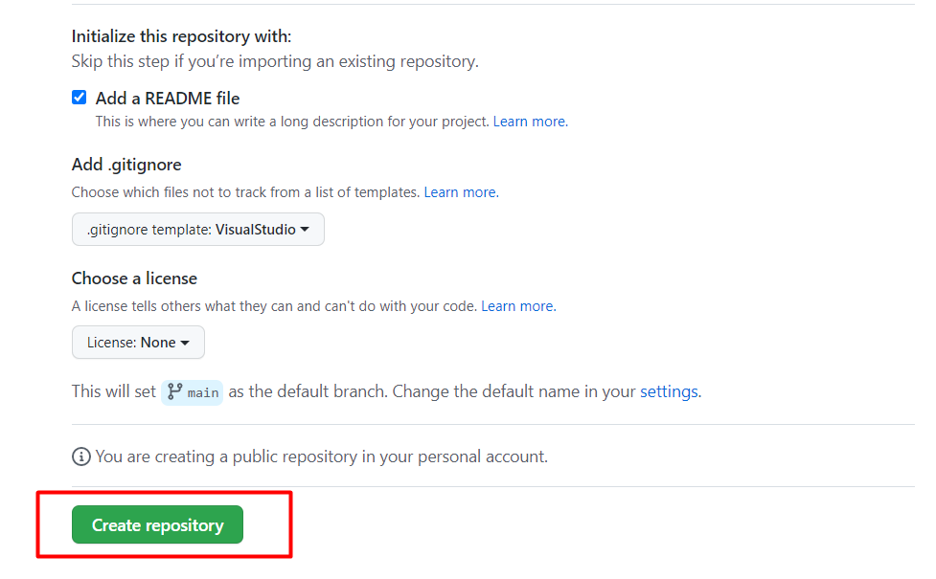

Now your **repository is created** and looks like this:

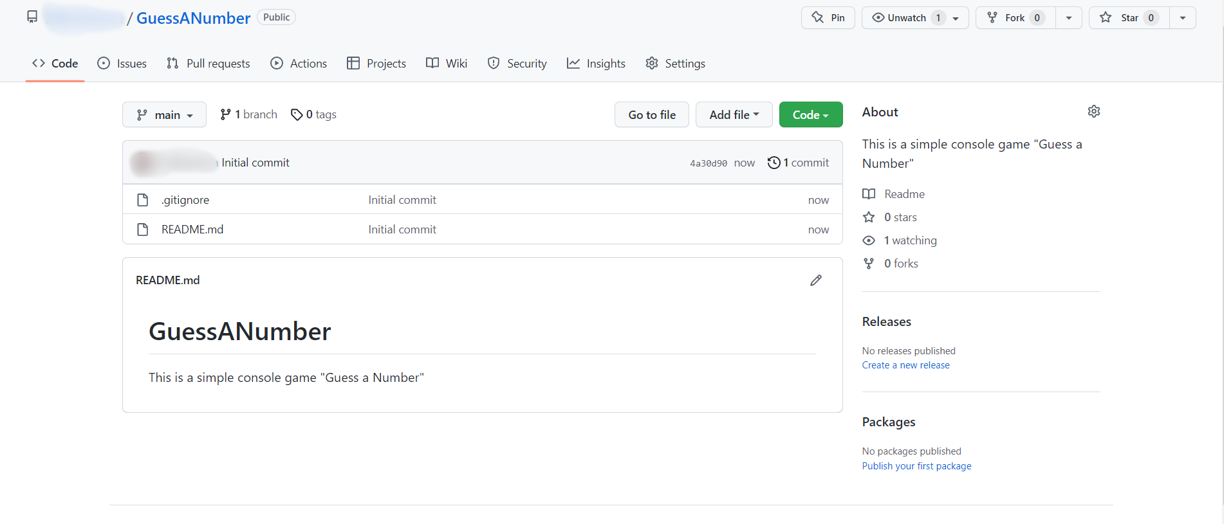

Now let's see how to **write the code** of our game.

## Write the Game's Code

Let’s create the game and play with it.

### Create a Visual Studio Code Project

First, we should **start Visual Studio Code** and **create a new JS file.** Then, **choose an appropriate name** and a **place to save the project.**

### Implement the Game Logic

Now let's start working on our project.

#### Read Player's Move

First, we should create an interface where we can enter the number without stopping the program:

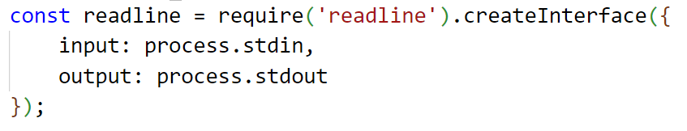

A little more information about how to create an interface: <https://nodejs.org/api/readline.html>

Create the already known **method** random, which will help us **choose a random number.** We will use this method so the computer can every time choose a number **between "1 and 100".**

You can learn a little more about it here:

<https://developer.mozilla.org/en-US/docs/Web/JavaScript/Reference/Global_Objects/Math/random>

Now create a function that stores the question about the number.

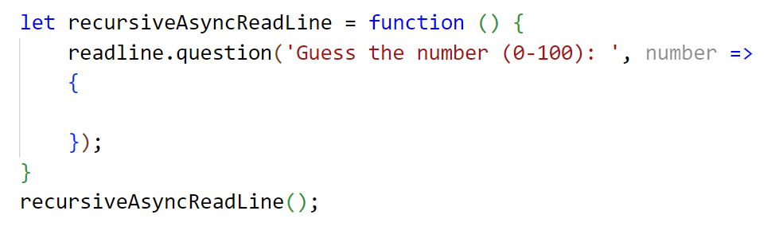

More about this **readline.question** you can learn: <https://nodejs.org/api/readline.html>

Now let's run the **app** in the console and check whether our current code **works** properly. Write in the terminal **node {your file's name}.js :**

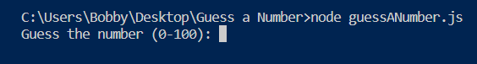

#### Check the Player’s Input

Now check the player's input using **Number(…).** If it's a number **(what we expect),** the methods will return a **number,** otherwise, **"NaN"**.

Now we have to create our if-else statements. First, we should check if the player's input data is valid:

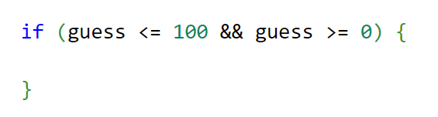

If data is valid, write a nested if-else statement in which we will check all **three** possible cases.

First, if the player’s number is **equal** to the computer’s number, that means the player **guessed** the computer’s number, so you should **write** a message and **stop** the application by using **readline.close()**. Do it like this:

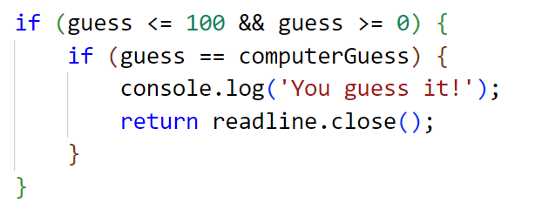

The other **two** cases are if the player's number is **higher** than the computer's number and the player's number is **less** than the computer's number. Write the rest of the else if statement by yourself: 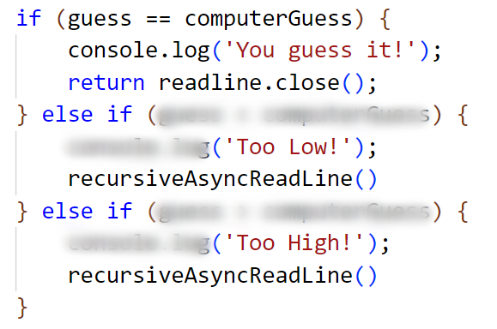

To create a **repeating** question after each **entered number**, we have to call the **same function** after every single answer that is **not** **the guess number**.

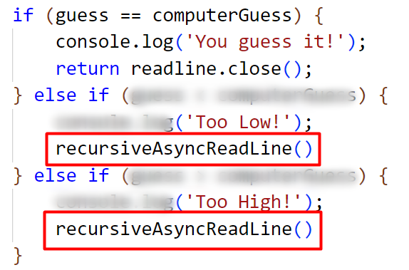

**Recursion** is a process of calling itself. A function that calls itself is called a **recursive function**. A recursive function must have a condition to stop calling itself. Otherwise, the function is called indefinitely.

Once the condition is met, the function stops calling itself. This is called a base condition. To prevent infinite recursion, you can use if...else statement (or similar approach) where one branch makes the recursive call, and the other doesn't.

More about recursion you can learn: <https://www.javascripttutorial.net/javascript-recursive-function/>

Now let's run the **app** in the console and check whether our current code **works** correctly:

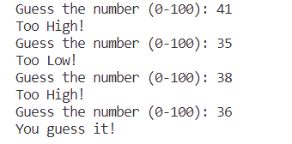

We can see that our application work's appropriately, but we are not finished yet.

#### Check for Invalid Input

Now what is left is to write else statement for the **final** case where the player’s input is **invalid.** That's all it takes for the **game to work**.

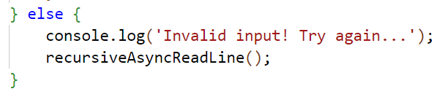

Your entire code should be similar to the following:

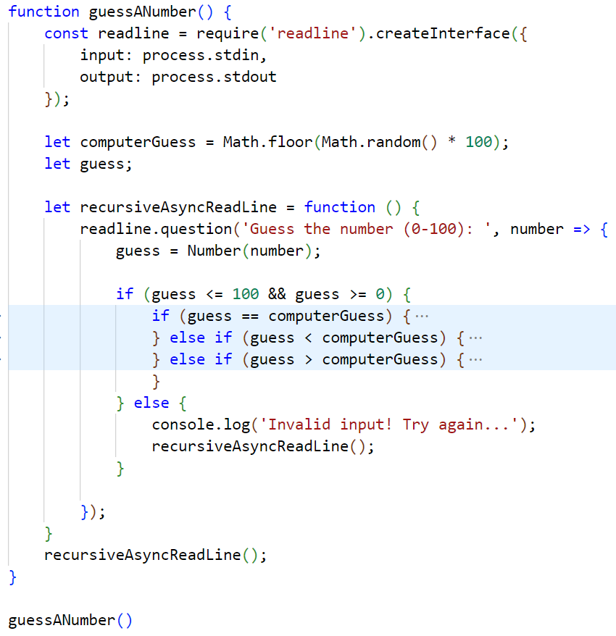

#### Test the Application

After you **run it**, the game should look like this:



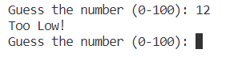

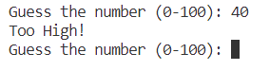



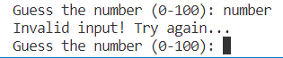

## Upload Your Project to Github

We already know how to clone our repository using **Git** **Bash** or **GitHub Desktop**.

### Use GitBash (Option 1)

Go to the desired **directory**, right-click on a blank space **anywhere** in the folder, and select "**Git Bash Here**" to open the Git command line console. If the "**Git Bash Here**" menu is missing, you should first install Git.

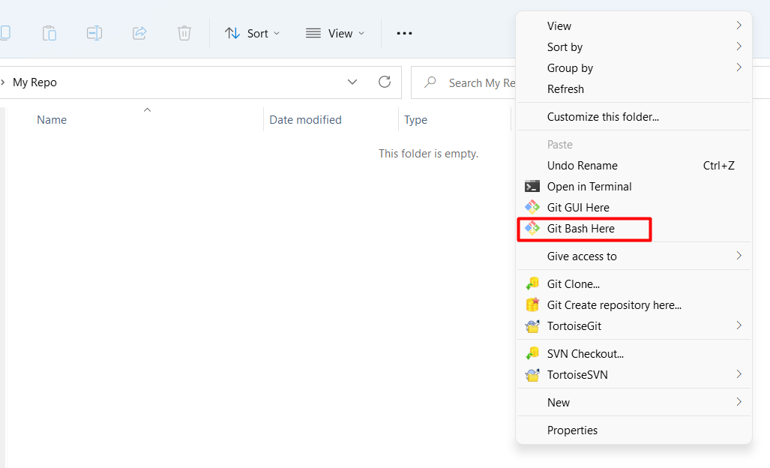

Type the **"**gitclone**"** command followed by the link to your **repository**:

gitclone

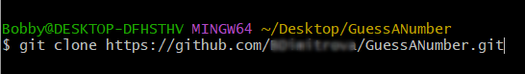

The result should be something like this:

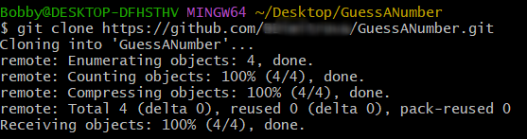

Your files from your GitHub repo will be downloaded to a **sub-folder** called your project in GitHub, "**GuessANumber**" in our case.

When we open the cloned **repository sub-folder**, it should look like this:

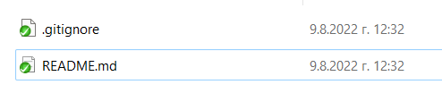

The next thing to do is to **add** your **project files** to your **cloned** **repository folder**. It should look like this:

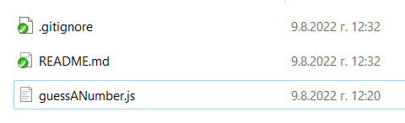

Now we are ready to upload our changes from the "**Git Bash clone**". Go to the desired **folder**, right-click on a blank space anywhere in the folder, select "GitBashHere" and run the following **commands**.

Type the following command:

|  |
| --- |
| git status |

The **git status** command displays the state of the working directory and the **staging area**.

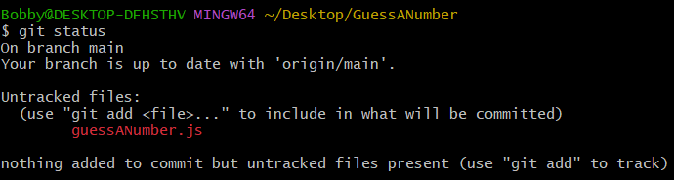

Now type:

|  |
| --- |
| git add . |

This command **adds** all modified files.

Next type:

|  |
| --- |
| git commit -m "Your message here." |

This command**commits** your changes. We also should **add** an appropriate **message**.

Second to the last type.

|  |
| --- |
| git pull |

This command **updates** your local **repository**.

Now the last thing that we should do is to **push** our changes by using the command:

|  |
| --- |
| git push |

This command **pushes** your changes to our local **repository**.

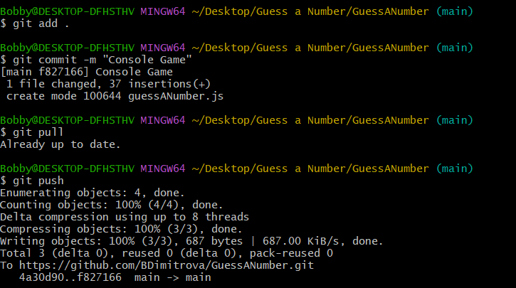

This is all you need to **update** your **repository** with **Git Bash**.

A little more information about it is here: <https://git-scm.com/about>.

### Use GitHub Desktop (Option 2)

If you don't have GitHub Desktop on your computer, download and install it from here: <https://desktop.github.com/>

Go to **"File"** and choose **"Clone repository".**

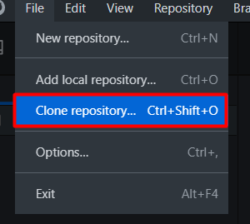

**Chose the repository** for the project, in our case, "GuessANumber" and hit the **"Clone"** button**.**

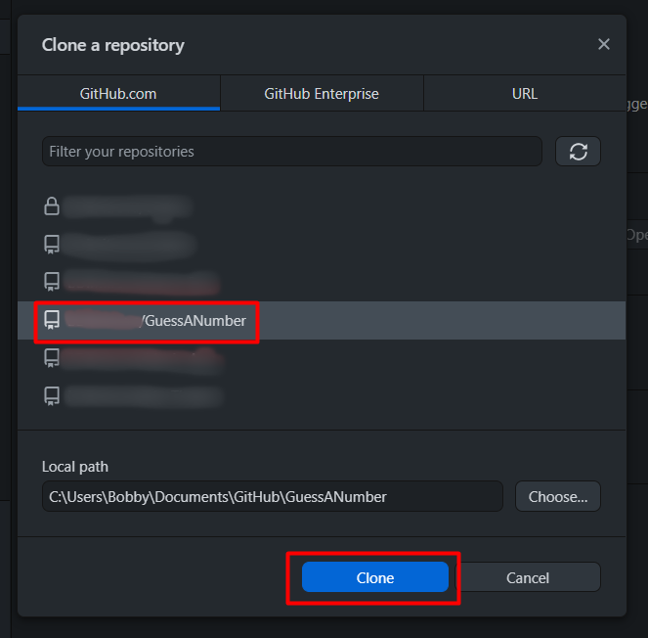

Your files from your GitHub repo will be downloaded to a **sub-folder** called your project in GitHub, "**GuessANumber**" in our case.

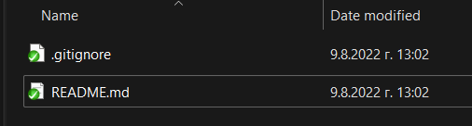

The next thing to do is to **add** your **project files** to your **cloned** **repository folder**. It should look like this:

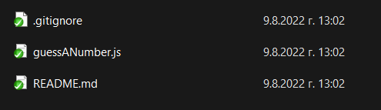

Afterward, go to GitHub Desktop and **create a commit**, just like this.

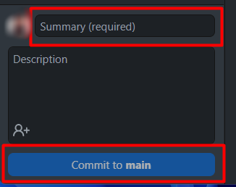

Then **push the commit** to the repository.

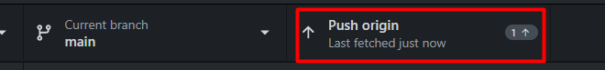

This is all you need to **update** your **repository** usingGit**Hub Desktop.**

## * Modify the Code, Write Your Features

Now, it's time to **play with the code** and **modify it**.

|  |  |
| --- | --- |
|  | This is your project. **Be unique**. Don't be a copy/paster!   * Implement your **features**. * **Implement the code yourself**, using your coding style, code formatting, comments, etc. * Make the project **more interesting**. Learn by playing with the code and adding your changes. |

Below are a few **ideas** of what you can implement or modify as an addition to your code.

### Add Difficulty

You can add logic for difficulty, so the player can have **only a few tries** to guess the number.

### Restart the Game

You can automatically **restart the game** after it is finished (or ask the player to play again).

### Additional Ideas

* You can **add levels** so whenever the player guesses the number, the range between the minimum and maximum number gets bigger, e. g. **Level 1 (1 - 100)**, **Level 2 (1-200),** etc.
* Can you add anything else to your code based on your ideas?

### Commit to GitHub

Now **commit and push your code changes** to your GitHub repo!

|  |  |
| --- | --- |
|  | It is very important to **commit your code frequently** to GitHub. This way, you create a **rich commit history** for your project, and your GitHub contribution graph is growing: |

## Create a README.md File

It's highly recommended to provide documentation as part of your project on GitHub to describe what the project is doing. So, let's make one for this **project**. Let's start by editing the README.md file from our repo on GitHub:

Add a project name.

You can **view** the current progress by pressing the [Preview] button:

### Documentation Sections

Add **information** about your project in your README.md file: project goals, technologies used, screenshots, live demo, etc. Typically, you should have the following **sections**:

* **Project title** (should answer the question "What's inside this project)
* **Project goals** (what problem we solve, e. g., we implement a certain game)
* **Solution** (should describe how we solve the problem 🡪 algorithms, technologies, libraries, frameworks, tools, etc.)
* **Source code link** (give a direct link to your source code)
* **Screenshots** (add screenshots from your project in different scenarios of its usage)
* **Live demo** (add a one-click live demo of your code)

### Use Markdown

Note that the GitHub README.md file is written in the **Markdown language**. Markdown combines text and special formatting tags to describe formatted text documents.

You can learn more about **Markdown** here: <https://docs.github.com/en/get-started/writing-on-github/getting-started-with-writing-and-formatting-on-github/basic-writing-and-formatting-syntax>.

### Project Goals

Start your documentation by describing your **project goals**. What problem does your project solve?

### Sample Documentation

This is an **example** of how you can document your project. Don't copy-paste it! 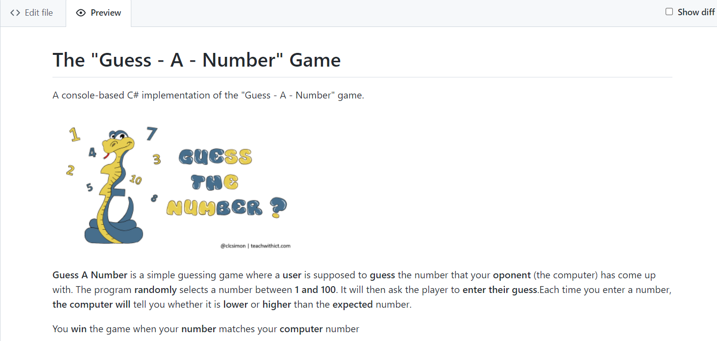

|  |  |
| --- | --- |
|  | **Write the project documentation yourself**. Don't copy/paste it!  This is your **unique GitHub profile** and your unique project. **Be different** from others. |

Find an **appropriate** **image** and add it. You can add **images** as follows:



You can add information about the **inputs** and **outputs** of the project:

### Your Solution

Describe how you **solve the problem**: algorithms, technologies, libraries, frameworks, tools, etc.

### Link to the Source Code

[Source Code](guess_a_number.py)

### Screenshots

Add **screenshots** of your project:

1. **Take a screenshot** with your favorite tool (e.g., the [Snipping Tool](https://support.microsoft.com/en-us/windows/open-snipping-tool-and-take-a-screenshot-a35ac9ff-4a58-24c9-3253-f12bac9f9d44) in Windows).
2. **Paste** the screenshot in the GitHub Markdown editor using [Ctrl+V]:

Example screenshots for the "Guess a Number" game:

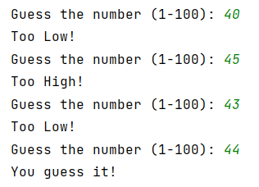

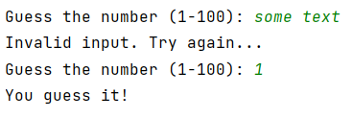

## Upload Your App to Replit

You already should have a **Replit** profile. Now let's add our **project** there so we can share it with our **friends** and add it to our **GitHub** profile. You already should know how to do that.

Open the **menu** in the upper **left corner**. Click "**Create**", then select the **language** in which your project is **written**, select a name, and **create** the project **Node.js**

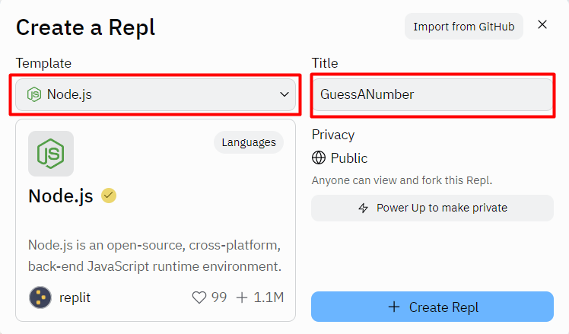

**Paste your code** in the "guessANumber.js" file:

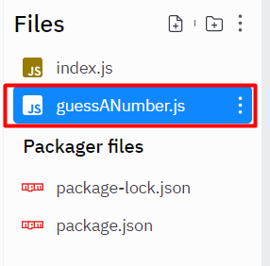

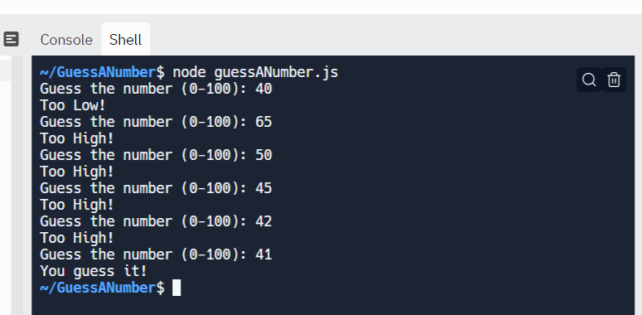

You can now **share** your app with your friends.

## Add Replit Link to Your README.md

Now add a "**one-click live demo**" of your project from your GitHub project documentation. You can do it as follows:

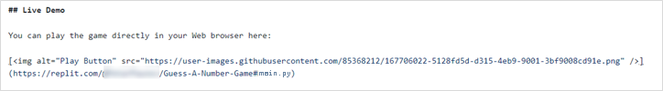

You can take a **screenshot** from Replit.com and **paste it** into the GitHub documentation editor directly with **[Ctrl+V]**.

Now we have completed our **second console game,** and we have our second **project** in our GitHub portfolio.